Hurricane Speed&Performance - Custom Connecting Rod Form
SPECIFY UNITS : MM OR IN
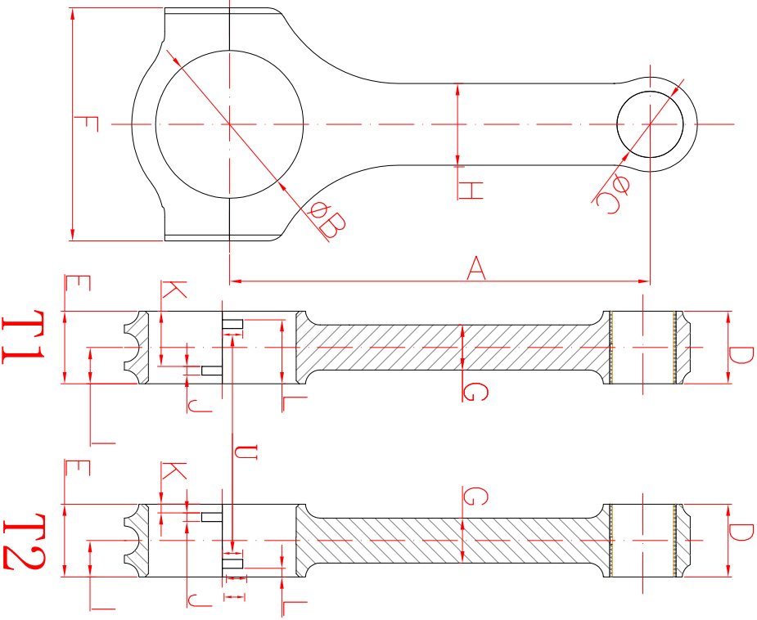
Center to Center length/中心距 | B.  Big End Bore/大孔
C.  Pin End Bore/小孔 | D.  Pin End Width/小端厚度
E.  Big End Width/大端厚度 | F.  Overall BE Width/肩宽
G.  Beam Thickness/杆厚 | H. _____  Beam Width/杆宽
I.  BE Offset | S. _____  T1 Or T2反瓦/正瓦
K. ______  Tang Position | J. _____  Tang Width/瓦槽宽度
V. _____  Tang Depth/瓦槽深度 | L. _____  Tang Position
U. _____  Tang Length/瓦槽长度 | M. _____  H-beam, X-bea, I-beam/设计
O. _____  Piece/Set 支/组 | N._____  Engine Model /发动机型号
P. _____  Bolt Diameter(Inch) /螺栓规格 | Q. _____  Piece ( Quantity)/数量
R. _____
Bolt Length(Inch) 螺栓长度
